JobMatch.com System Level Use Case Diagram and One Use Case

|  |  |
| --- | --- |
| Prepared for: | Jim Buchan |
| Prepared by: | Mao Chuan Li |
| Student ID: | 14854389 |
| Prepared by: | Chen Xiao Yu |
| Student ID: | 15855860 |
| Submit Date: | 2015/04/28 |
| Paper Name: | Software Requirements Engineering |
| Paper Number: | 409220 |

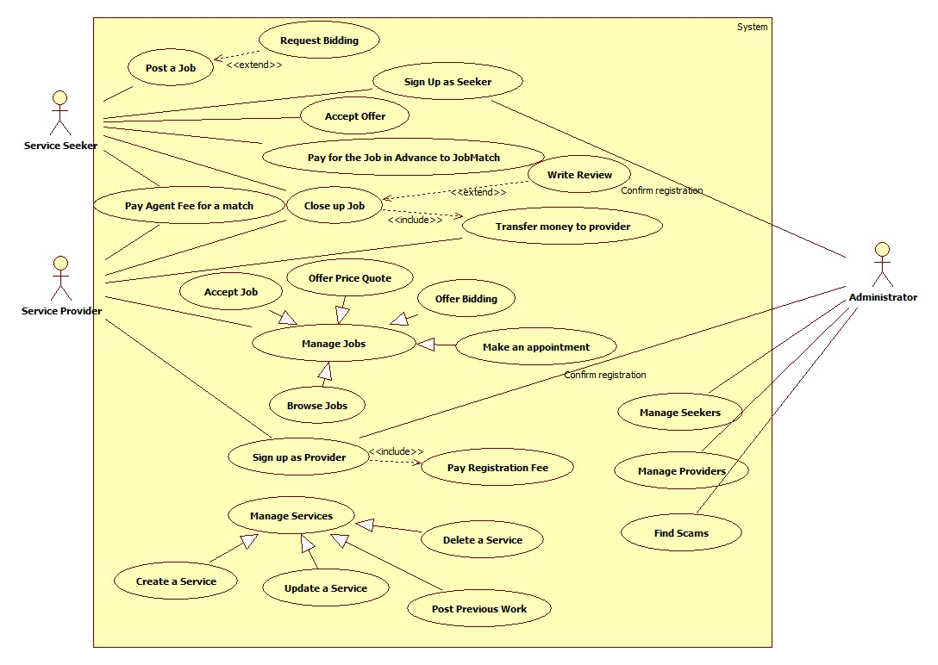

**Use Case**: Post a Job

**Primary Actor:** Service Seeker

Scope: JobMatch.com website

Brief: The service seeker can post a new job to JobMatch.com

**Level:** User Goal

**Precondition:** Seeker logged into JobMatch.com as a service seeker, and the home page is shown with a “Post a Job” button enabled

**Minimal Guarantees:** None

**Success Guarantees:** A new job posted to JobMatch.com successfully

**Triggers:** A user clicks the “Post a Job” button on the home page

**Main Success Scenario:**

1. The JobMatch.com system opens a new web page named “New Job”
2. A list of Job Description detail fields are listed in the web page
3. The seeker inputs the job details till he is satisfied
4. The seeker inputs a price for the job
5. The seeker clicks the ‘submit’ button to publish the job
6. The JobMatch.com receives the request, generates log for it, and saves it to database
7. The JobMatch.com redirect the seeker back to his home page, where there is a new job listed in the Job List.

**Extensions:**

4a: The seeker leave the price field empty, waiting for bidding from each provider.